
© P.O. Box 225076 ● Dallas, Texas 75222

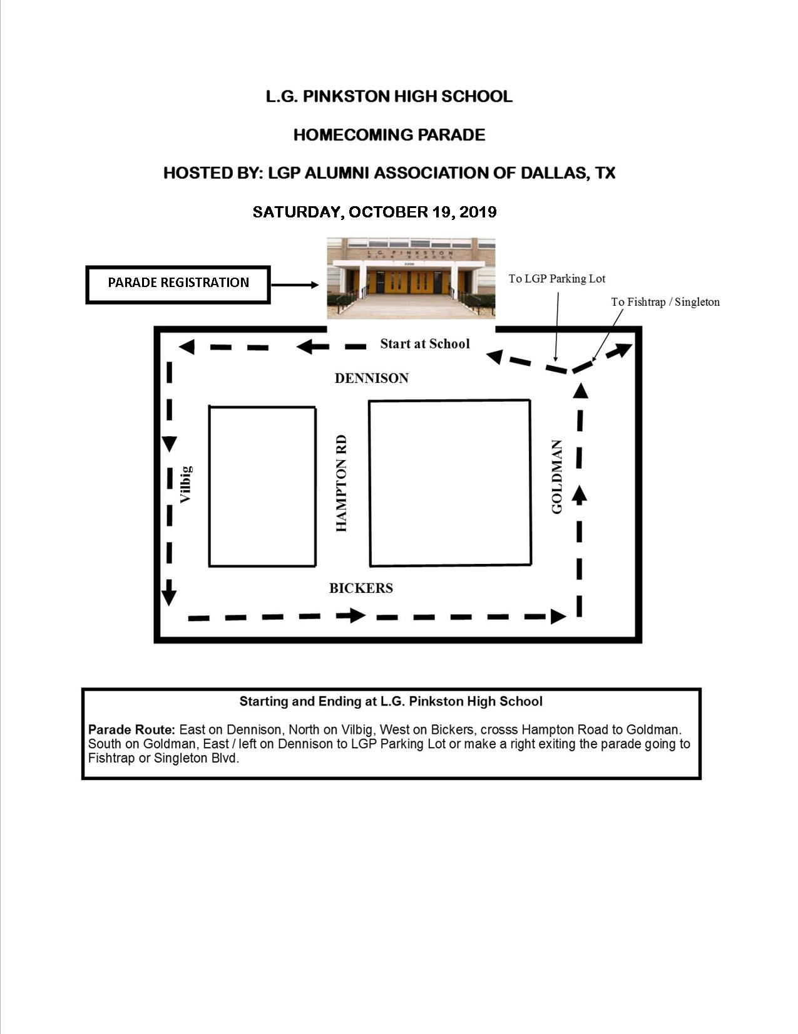
ADDITIONAL FORMS BELOW

© P.O. Box 225076 ● Dallas, Texas 75222

2019 LGP HIGH SCHOOL HOMECOMING PARADE

PARTICIPANT REGISTRATION FORM

I, ___________________________________ hereby submit this Registration Form to enter in the LGP High School Homecoming Parade, to be held on Saturday, October 19, 2019
.

Name of Organization / Class / Business / School, Other:

________________________________________________________________________

Contact Person: _____________________________ Phone: ______________________

Cell/Other: ________________________
Address:

City/State/Zip: ____________________________________________________________

Email: __________________________________________________

PLEASE PROVIDE PHONE NUMBERS IN CASE OF AN EMERGENCY OR CHANGES.

● ● ● ● ● ● ● ● ● ● ● ● ● ● ● ● ● ● ● ● ● ● ● ● ● ● ● ● ● ● ● ● ● ● ● ● ● ● ● ● ● ● ● ● ● ● ●
ENTRY FEE IS $20.00 FOR ALL MOTOR VEHICLE ENTRIES
□ Car □ Limo □ truck □ Van □ Motorcycle □ Scooter

NO ENTRY FEE FOR PARTICIPANTS BELOW

□ Local Representative Name and Office: _____________________________________

_____________________________________

□ School / School Groups □ Community Center □ Church □ LGPAADT Sponsors
□ Marching Band □ Drumline □ Military / ROTC □ Walking □ Bicycles
□ Steppers (school, sorority, church) □ Neighborhood Associations
□ Alumni Ms. & Mr. Pinkston (Other) □ Little League Teams (cheerleaders, dancers)
□ Dancers (Children, Adults): will you have music? Please check the appropriate box below. □ YES, we will have our own music □ NO, please place us behind a vehicle with music.

******************************************************************
LGPAADT is NOT RESPONSIBLE FOR SIGNAGE
If your entry uses music - LGPAADT is not responsible for electrical or cordless usage.

Pre-Registration - Deadline for entries: Friday, October 18, 2019.
Mail in registration form to the address above or forward to info@lgpalumni.org
Entry Fees must be paid in full before the event starts.

ONSITE REGISTRATION OPENS AT 10:00 AM
Entry fees are non-refundable.
Proceeds will go towards the Educational and Activity Programs, and Scholarships at L.G. Pinkston High School, sponsored by the L.G. Pinkston High School Alumni Association

ADDITIONAL FORMS BELOW
© P.O. Box 225076 ● Dallas, Texas 75222

PARTICIPANT RELEASE OF LIABILITY

“L.G. PINKSTON HOMECOMING PARADE”
Hosted by L.G Pinkston High School Alumni Association of Dallas, Texas

Saturday, October 19, 2019

Participants in the Homecoming Parade are required to read and sign the following.

I, the undersigned, as participant or as the representative of participant(s), group or organization, and any others with me, hereby release the Homecoming Parade Sponsors and L.G. Pinkston High School Alumni Association of Dallas, Texas and their volunteers or affiliates from any known or unknown damages, injuries, losses, judgments and/or claims including, without limitation, property damage in my parade unit and personal injury, however the forgoing may occur and regardless of how it may occur, recognizing that I, and any other accompanying me, specifically assume any and all said risks. Further, each entrant expressly agrees to indemnify all of the foregoing entities, and persons from any and all liabilities resulting from the conduct of entrants, spectators, or any participant assisting or cooperating with entrant and under direction or control of entrant.

INDIVIDUAL: I have read, understand and accept the conditions of this Release of Liability.

Name: _________________________________________ Phone: ____________________
Please Print
Address: _______________________________ City/State/Zip: _________________________

Signature: _________________________________________ Date: __________________
Signature required in order to participate

ORGANIZATION / SCHOOL / CLASS / BUSINESS / OTHER:
If representing an organization/school/class/business/other, please note that the signee will be responsible for all parties participating under the group name below.

Name: ____________________________________________ Phone: __________________
Organization/School/Class/Business/Other

Address: _______________________________ City/State/Zip: __________________________

I have read, understand and accept the conditions of this Release of Liability.

Responsible Party: _________________________________ Date: ____________________
Signature required in order to participate

ADDITIONAL FORMS BELOW
© P.O. Box 225076 ● Dallas, Texas 75222

PROOF OF LIABILITY AND RELEASE OF LIABILITY
MOTOR VEHICLE ENTRY

“L.G. PINKSTON HOMECOMING PARADE”
Hosted by L.G Pinkston High School Alumni Association of Dallas, Texas

Saturday, October 19, 2019

Responsibility / Owner of Vehicle:

The Organizer accepts no responsibility or liability for the consequences of you being involved in an accident. Any cost to your vehicle incurred during your participation are your own responsibility. You will need to have a valid driver license and proof of insurance inside your vehicle. Failure to do so may prevent participating in the LGP Homecoming Parade.

It is your responsibility to ensure that you and your vehicle are compliant with locally applicable laws.

All information that the Organizer requests from you in relation to your own personal vehicle must be accurate and complete in all material respects and by signing this document you agree that it is in its entirety.

In consideration of the right to participate in the parade. I, hereby release the Homecoming Parade Sponsors and L.G. Pinkston High School Alumni Association of Dallas, Texas from any known or unknown damages, injuries, losses, judgments and/or claims including, without limitation, property damage in my parade unit and personal injury, however the forgoing may occur and regardless of how it may occur, recognizing that I, and any other accompanying me on or about my parade unit, specifically assume any and all said risks. Further, each entrant expressly agrees to indemnify all of the foregoing entities, and persons from any and all liabilities resulting from the conduct of entrants, spectators, or any participant assisting or cooperating with entrant and under direction or control of entrant.

Owner of Vehicle: I, ____________________________________ have read, understand and accept the conditions of this Release of Liability.

Number of Vehicles: __________ Address: _______________________________________

City/State/Zip: __________________________ Phone: _______________________________

Owner of Vehicle: _____________________________________ Date: ______________
Signature

LGPAADT OFFICE USE ONLY

LGPAADT: ____________________________________________ DATE: _____________

READ CITY OF DALLAS RULES AND RULATIONS BELOW
© P.O. Box 225076 ● Dallas, Texas 75222

CITY OF DALLAS RULES AND REGULATIONS
Conditions and Restrictions



City of Dallas conditions and/or restrictions under which the parade permit was issued to LGPHS Alumni Association of Dallas, Texas.

- Parade participants obey all traffic laws at intersections not controlled by a Dallas Police Officer.

- All parade participants who drive floats or motorized vehicles shall have a valid driver’s license and vehicle liability insurance.

- All parade participants must stay in the designated lanes of traffic.
DIRECTED BY OFFICERS AND PARADE VOLUNTEERS

- All parade participants riding or standing on floats or motorized vehicles must wear safety belts, have hand holds or back supports securing them in place while the float or vehicle is in motion.

- No candy or materials may be thrown alone the parade route. The distribution of gifts, merchandise, literature or other material alone the parade route is prohibited unless prior approval is given by the parade director.

- Squirt guns, silly string or other items potentially dangerous to spectators or participants are prohibited during the parade.

- HORSES – NOT ALLOWED.

- Please refrain from the use of alcoholic beverages during and after the Parade. Anyone disobeying this rule will be removed from the Parade / School Property by a City of Dallas Police Officer. Your entire unit/group will be escorted from the Parade / School Property.

NOTE: THERE WILL BE NO PRODUCTS OR MECHANDISE SOLD DURING THE PARADE OR TAILGATE.

